Experiment 1 Measurements Errors and Uncertainty
- Caliper
- Ruler

Physics and Measurement
Physics is one of the most fundamental sciences. It deals with behavior and structure of matter. It is based on experimental observations and quantitative measurements. In order to identify meaningful relationships that characterize nature, it is important to know how to measure physical quantities in terms of which the laws of physics are stated.
Physical quantities are not generally independent to one another. Physics is composed of seven fundamental quantities. In mechanics, there are three fundamental quantities which are length, mass and time. The other quantities used in mechanics can be derived in terms of these three. The other four are; current, thermodynamic temperature, amount of substance and luminous intensity.

International System of Units (SI Units)
To make accurate and reliable measurements, a standard must be defined that do not change in various locations. Scientists and engineers all over the world use the same system of units as a standard to measure physical quantities.
This system is the International System of Units (SI Units). It is based on the metric system and basic set of units including meter, kilogram and second. The SI base units are given in the Table 1.
Table 1. Fundamental quantities and their units
Base Quantity | SI Base Unit | Symbol
Length | meter | m
Mass | kilogram | kg
Time | second | s
Current | ampere | A
Thermodynamic Temperature | kelvin | K
Amount of Substance | mole | mol
Luminous Intensity | candela | cd

Table 2. Commonly used prefixes
Power of ten | Prefix | Symbol
-15 | femto | f
-12 | pico | p
-9 | nano | n
-6 | micro | μ
-3 | milli | m
-2 | centi | c
3 | kilo | k
6 | mega | M
9 | giga | G
12 | tera | T

The Prefixes
In metric system, the larger and smaller units are defined in multiplies of 10 from the standard unit. Commonly used prefixes are listed in Table 2.

Types of Measurements
In general, measurements are divided into two groups, namely direct and indirect measurement. Direct measurements of a physical variable are obtained by the reading of the scale of an instrument calibrated in the corresponding units of the variable.
Example of a direct measurement is that measuring a certain length with a ruler. Indirect or calculated measurements are the deduction of the magnitude of physical variables using mathematical operations with magnitudes obtained by direct measurements.
In general terms, indirect measurements are those that correspond to physical variables whose values have not been determined by an instrument that can measure them directly. As an example, calculation of a sphere (of which radius, , is measured initially) by the formula of
$V=$ $\frac{4}{3}$ $πr^{3}$

Errors
No physical quantity can be measured with a perfect certainty; there are always errors in a measurement. It is simply an observed fact that when independent measurements are repeated on a physical system, all the measured values will not generally be exactly the same. In general, the types of errors in a particular experiment may be due to the observer, experimental equipment or the design of the experiment. In recording a measurement, it is important to estimate and record the error. Error in a measurement can be indicated by making a reasonable assessment of the accuracy of the measurement in terms of the sources of errors and estimating the maximum possible error in the measurement. Then, the result of the measurement is written by the maximum possible error using the symbol “±” followed from the value observed from the scale. As an example, consider “x” is the actual measurement and “Δx” is the maximum reading error, then the result of the measurement is written as “x±Δx”.

Types of Errors
There are two types of errors which are systematic errors and random errors.

Systematic Errors
The source of systematic errors is due to the imperfections of the measuring instruments. Systematic errors are fixed errors and for each measurement, this fixed error value is either subtracted or added.
For instance, when a voltmeter without its reset setting done shows 0.1 volts when not in use, then an excess value of 0.1 volts is taken into consideration in all measurements we conduct with the same voltmeter. If 0.1 volts are subtracted from all measurements, the correct measurement value is obtained. In carrying out an experiment, it is important to consider possible sources of systematic errors and to take precautions to eliminate them during the construction and calibration of the instruments.

Random Errors
These errors arise from unknown and unpredictable variations in the experimental situations. Random errors are generally very small and the chances of errors being positive or negative are equal. These random errors emerge due to the diversity of the mechanism and may not be completely removed (as mentioned in our example given for systematic errors) from the experiment results. These errors require statistical analysis because of their randomness. The best way to determine random errors is to repeat the same measurement more than once. However, we will use another method since it is not always possible to make repeated measurements: the error in a measurement device is equal to the smallest amount that device can measure.
Random Errors in Position Measurements
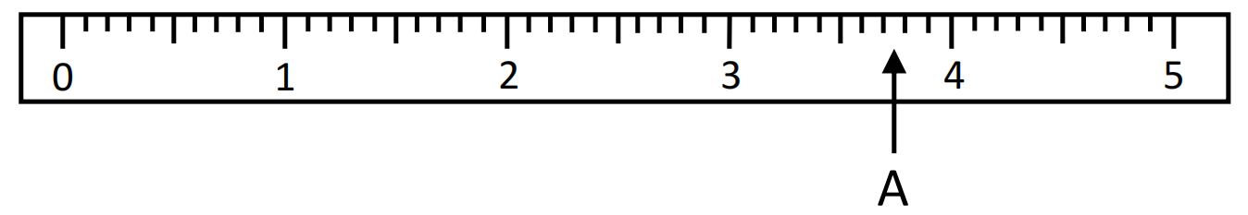
Figure 1. Measuring the position of A using a ruler.
Let us assume we are making a measurement with a ruler. The error in the ruler is equal to the smallest segment length on the ruler. For example, as seen in the Figure 1, we are measuring a position measurement of a point A with a ruler divided into “mm” segments and find the result to be 3.7 cm. A reading may appear in between points 3.7 and 3.8 cm.
Because the smallest quantitative value of our device can measure is 1 mm which is standard for all position measurements with this ruler, then, we write our result as 3.7 ±.0.1 cm Thus, we may mention that a ruler divided into millimeters is more reliable than one divided into centimeters.
Random Errors in Length Measurements
It is a measurement error in determining a distance between two points in one dimension.
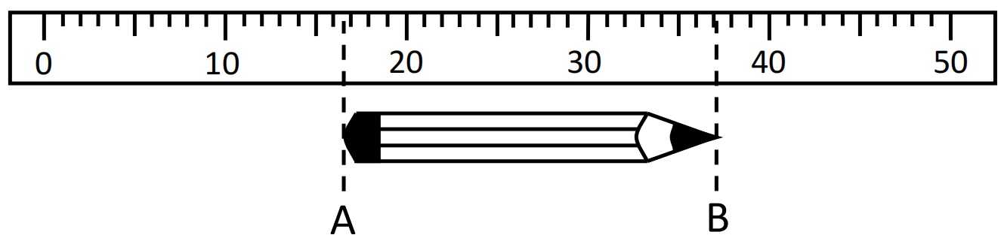
Figure 2. Measuring the length of a pencil using a ruler.
As an example, in the Figure 2, let us measure the length of a pencil using a ruler. The length of the pencil is calculated by the difference between the end points of A and B. Therefore, the positions of these two points should be measured with respect to the same reference point. Each position measurements come with an error of 1 mm. Therefore, the error of this measurement is 2 mm. As seen in the figure, we can read the position of point A as 17 cm and position of point B as 37 cm with respect to the “0” point on the scale of the ruler. Then, we write our result as:
L ± ΔL =(37-17) ± 0.2cm = 20 ± 0.2 cm
As being experienced in this example, the effect of random errors can be reduced by improving the experimental technique and repeating the measurement many times and taking the average.
- The scale of a measuring instrument is not exact.
- The exact reading of a scale is impossible.
- The exact measurement of any quantity is impossible.
- No experiment gives the right answer.

Accuracy and Precision
Experimental errors are the difference between a measurement and the true value or between two measured values. Under the effect of these errors, the reliability of the measured values are analyzed by its accuracy and precision. Accuracy and precision are two important factors to consider when taking data from measurements. The accuracy of an experiment is a measure of how close the experimental result comes to the true (or accepted) value. It is related to a measure of the correctness of the result. Source of systematic errors determines how accurate the measurement is. The precision of an experiment is a measure of how reproducible the result is. That is, it is a measure of the magnitude of the uncertainty of the result due to random errors. It is related to a measure of repeatability of the result and therefore, it is usually limited by the sources of the random errors.
Both accuracy and precision reflect how close a measurement is to an actual value, but accuracy reflects how close a measurement is to a known or accepted value, while precision reflects how reproducible measurements are, even if they are far from the accepted value
To clarify these definitions, consider an example about throwing and striking a bullet to a target (Figure 3).
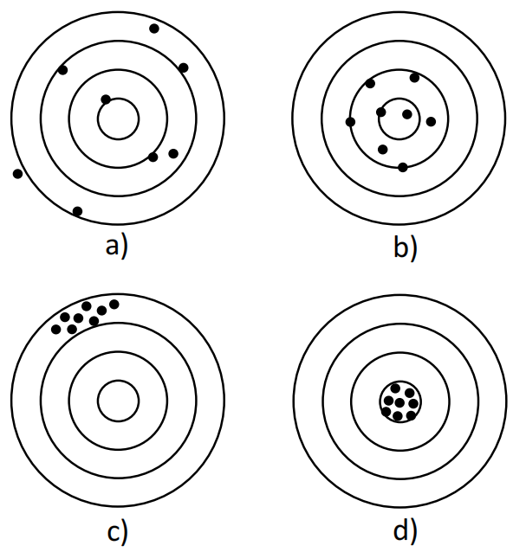
In the Figure 3, in the Part-(a), there is an example showing an example of striking which is neither precise nor accurate. Because the aim of throwing the bullets is to hit the target on its center, they are not in the middle of the inner circle and also the differences between them are very large. Part-(b) shows an example of striking which is accurate but not precise. As compared to the results in part-a, the bullets are near the center of the target but they are not close to each other. Part-(c) shows an example of striking which is precise but not accurate. As seen in Part-(c), the bullets are in a group which means the results are approximately the same; the difference between the bullets is very low. However, they are not located near the center of the target. Lastly, Part-(d) shows an example of striking which is both accurate and precise. This means that each of the trial gives the true (accepted) result, the bullets are located near the center of the target, and also, they give the similar results, the difference between the bullets is small.
Figure 3. The difference between accuracy and precision.
The accuracy of an experiment often depends on both systematic and random errors. The precision of an experiment typically depends on random errors.

Significant Figures
When certain quantities are measured, the measured values are known only to within the limits of the experimental uncertainty. The number of significant figures in a measurement can be used to express something about the uncertainty. The number of significant figures is related to the number of numerical digits used to express the measurement.
The degree of certainty of a measurement is implied by the way the result is written or reported. While reading the value of an experimental measurement from a calibrated scale, only a certain number of digits can be obtained or read. Significant figures are those figures which are known to be reasonably trustworthy; they are figures actually obtained from the measuring instruments, including zeros and estimated figures.
The position of the decimal point does not affect the number of significant figures. If a zero is used to locate the decimal point, it is not significant, but if it actually represents a value that is read on the instrument, or estimated, then it is significant.
Give the figures you read from a scale with only the last figure estimated as a result of measurement. Never put extra figures. The digits including the last one estimated are called significant figures.
The number of significant figures in a measurement is determined as follows:
- The leftmost nonzero digit is the most significant.
- If there is no decimal point, the rightmost nonzero digit is the least significant.
- If there is a decimal point, the rightmost digit is the least significant, even if it is zero.
- All digits between the least and most significant digits are considered to be significant.
Pay attention to zeroes whether they are significant or not.
As an example, the numbers in the following list of numbers all have four significant figures. There is an explanation for each.
- 6739: All four nonzero digits are significant.
- 456900: The last two zeros are not significant because there is no decimal point.
- 0.008589: Zeros at the left are never significant.
- 0.01000: The zero at the left is not significant, but since there is a decimal point, the three zeros at the right are significant.
- 10.60: There is a decimal point, so all four numbers are significant.
- 1.057: Again, there is a decimal point, so all four are significant.

Scientific Notation
Physics deals with some very large and very small numbers. The scientific notation is a convenient method to express numbers rather than conventional notation. Scientific notation also allows numbers to be expressed in a form that clarifies the number of significant figures. The exponent in scientific notation is equal to the number of times that the decimal point must be moved to produce a number between 1 and 10.
Write the result of a measurement as two factors; the first factor contains all the significant figures, having one nonzero digit in front of the decimal point, and the second factor is a power of 10.
Examples for the usage of this notation are given below;
- 255 mm = 2.55 x 10² mm
- 11.1 cm = 1.11 x 10¹ cm
- 0.0125 km = 1.25 x 10⁻² km
- 360 g = 3.60 x 10² g

Calculation with Significant Figures
The calculations carried out with significant figures usually produce extra figures as a result of calculation. It is important that the calculations should be consistent with the values that have measured. The value with the least significant digits sets the standard for the degree of accuracy for the measurements. This means that the result calculation should have only one estimated figure.

Rounding Numbers
The result of the measurements can be rounded off to the desired number of significant figures before they are used in calculations. The rules for rounding of the numbers are:
- If the last figure is less than 5 (0, 1, 2, 3 or 4), it should be dropped and the others should be unchanged.
- If the last figure is equal to 5 or greater (5, 6, 7, 8 or 9), it should be dropped and the numerical result should be increased by 1.
For instance,
- 2.431 may be rounded off to 2.43 when rounded off to the nearest hundredths place.
- 2.431 may be rounded off to 2.4 when rounded off to the nearest tenths place.
- 2.431 may be rounded off to 2 when rounded off to the nearest units place.
- 6.587 may be rounded off to 6.59 when rounded off to the nearest hundredths place.
- 6.587 may be rounded off to 6.6 when rounded off to the nearest tenths place.
- 6.587 may be rounded off to 7 when rounded off to the nearest units place.

Multiplication and Division
In the multiplication or division of the numerical results, the result should be rounded off to the least number of significant figures used in the calculation. For example,
$$\frac{\begin{matrix} 3.519 \\ x 2.3 (least significant)\end{matrix}}{\begin{matrix}10557 \\ \frac{+ 7038 }{8.0937 \left(≈8.1\right) }\end{matrix}}$$ | $$\frac{\begin{matrix} 3.5 (rounded off) \\ x 2.3 \end{matrix}}{\begin{matrix}105 \\ \frac{+ 70 }{8.05 \left(≈8.1\right) }\end{matrix}}$$
As can be seen from the example, since the least number of significant figures is 2, the result is rounded off 2 significant figures.
The same result can be obtained by rounding off the all multipliers to the least number of significant figures before the multiplication.
102.35 | ⇒ | 10235 | 1572
15.72 |  | -9432 | 6.5108 | (≈6.511)
8030
_7860
 |  | -7860
 |  | 1700
 |  | -1572
 |  | 12800
 |  | -12576
 |  | 224
The example above shows a division of two measured values. Similar to the multiplication case, the number of significant figures of the result should be equal to the number of significant figures of the value with the least number of significant figures. Therefore, the result has 4 significant numbers.
In the multiplication or division of numericalmeasurements, retain in the result only as many figures as the number of significant figures in the least accurate number used in the calculation.

Addition and Subtraction
When the numerical results are added or subtracted, the answer can contain no more decimal places than the least accurate measurement. This means that the number of places after decimal point in the answer should be less than or equal to the number of decimal places in each term in the calculation. For example,
$$\frac{\begin{matrix} 0.073 \\ 13.7 \\ + 156 \end{matrix}}{ 169.773 }\begin{matrix} \\ \left(≈170\right)\end{matrix}$$
The same result can be obtained by rounding off the all terms to the least accurate terms in the calculation before addition.
When carrying out addition or subtraction with numerical measurements, do not carry the result beyond the first column (from the left) that contains a doubtful digit.

Errors in Calculated Results
In the real case measurements, obtained physical quantity should be written with errors of the measurement. Whenever the measurements are used in calculations, the error should be used in these calculations to move each uncertainty of the measurements to the final result.
To work on the usage of errors in the calculations, assume that there are two recorded measurements as
x±Δx and y±Δy.

Addition and Substraction
In these calculations, the maximum possible error in the final result is the addition of errors from these measurements.
For addition:
R ± ΔR = (x ± Δx) + (y ± Δy) = (x + y) ± (Δx + Δy)
For subtraction:
R ± ΔR = (x±Δx) - (y±Δy) = (x - y) ± (Δx + Δy)
When measured quantities are added or subtracted, the maximum possible error in the result is the sum of the errors in the quantities used in the calculation.
The multiplication and division of two measured data is a little complicated than the previous calculations. They are performed as follows:
For multiplication:
R ± ΔR = (x±Δx) ⋅ (y±Δy) = x ⋅ y ± x ⋅ y ⋅ $\left(\frac{∆x}{x}+\frac{∆y}{y}\right)$
In this case, the first term is the division of the actual measurements and second term is its corresponding error.
For division:
R±ΔR = $\frac{(x ± ∆x)}{(y ± ∆y)}$ = $\frac{x}{y}$ ± $\frac{x}{y}\left(\frac{∆x}{x}+\frac{∆y}{y}\right)$
In this case, the first term is the division of the actual measurements and second term is its corresponding error.

Expressing Errors (Statistical Overview)

Average (Mean) Value
As mentioned in the types of errors part, random errors can be minimized by repeating the measurements several times. It is expected to obtain similar results for all trials. For this set of measurements, the actual result is most probably obtained by the average value. The average or mean value of a set of measurements can be expressed as:
$\overline{x}$ = $\frac{x_{1}+x_{2}+x_{3}+⋯+x_{n}}{n}$

Average Deviation of the Mean
Taking the average value of a series of measurements due to the random errors, there is a difference between each result of the measurements from the average value. This deviation d_{i} of any single measurement x_{i} is written as:
$d_{i}=x_{i}-\overline{x}$
When using the average value of the results, the best estimated error is defined as the average deviation of the mean (A.D.):
A.D. = $\frac{d_{1}+d_{2}+d_{3}+⋯+d_{n}}{n}$

Standard Deviation
The precision of the measurements can be determined by calculating a quantity called standard deviation from the mean of the measurements. The standard deviation represents the average of the square of the variation of individual measurements about the average value. It is defined as:
σ = $\sqrt{\frac{d_{1}^{2}+d_{2}^{2}+d_{3}^{2}+⋯+d_{n}^{2}}{n}}$

Absolute, Fractional and Percentage Errors
The error in a measured quantity may be expressed either as the absolute error, the fractional (or relative) error or percentage error. The absolute error is defined as the magnitude of difference between actual and measured value and it has the same units as the measured quantity. For example, a distance measurement made with a ruler marked in millimeters can be expressed as 25.5 ± 0.2 cm. The absolute error in this quantity is ± 0.2 cm.
Fractional error is the ratio of the absolute error to the quantity and it has no unit. It can be expressed as:
Fractional Error = $\frac{Absolute Error}{Actual Value}$
It is commonly expressed as a percentage error of a measurement to give the error to the actual value multiplied by 100.
Percentage Error = Fractional Error X 100%
The number of decimal places of the error part should be same with those of measurement.
For example,
- 25 ± 1 (true)
- 13.25 ± 0.05 (true)
- 25.2 ± 0.12 (false)
- 12.5 ± 0.5 (true)

Graphs
Graphing is a way of displaying relations between various quantities, parameters, or measurable variables in the measurements for clarity. Basically, it is a visual picture of the quantitative relationship between the physical quantities defining how one quantity changes if another quantity that is related to it also changes in the measurements.
Generally, in basic physics experiments, two-dimensional graph is enough to represent the relation between two related variable physical quantities. In these types of graphs, the horizontal axis (x-axis or abscissa) is used for the independent variable, and the vertical axis (y-axis or ordinate) is used for the dependent variable. For example, in a free fall experiment, assume that the measurement is done to determine the height h from the ground of a ball falling freely. In this case, the dependent variable h is investigated with the independent variable time t.
Moreover, in all plotting procedures, one of the most important points is to define the location of the data points obtained from the measurement according to the reference point called as the origin. It means that, any data point in the two-dimensional graph can be symbolized as (x, y) which refers to its coordinates on the x and y axis, with respect to the origin (0, 0).
Because the aim of usage of the graphs is summarizing a lot of information into one picture, a graph should be self-explanatory. The guide lines of graphs expecting from the experimental works are:
- Write the title of the graph
- Show x and y labels clearly
- Specify units on the axis
- Scale the axis correctly
- Identify the data points clearly
- Show the error bars
- Draw a best and a worst line
- Show equation of the slope and y-intercept

Title of the graph
Each graph should have a title. The title is related to the variables that will be plotted. It is very important that someone should figure out easily what is plotted. A title is usually written for example “Distance (D) versus Time (t)” or “Voltage (V) versus Current (I)”.
Label and the Unit of the Axes
x and y-axis should be labeled according to the experimental data. Labels on the axes should have a unit. For instance, for the x-axis which is used for the independent variable can labeled as “Time (seconds)” and y-axis can “Distance (meter)”.
Scaling of the axis
First of all, the data numbers should be observed in order to determine how big a graph to make. Scaling should be appropriate so that the data points are distributed as widely as possible over the area of the graph paper. The independent variable lies on the xaxis and dependent variable lies on the y-axis. The data values are examined separately to fit the axes. The scalings may be different on each axis and does not necessarily need to start from zero. Each axis must be divided into equal parts in itself. The starting and the end points of the axis are determined by subtracting the error part from the minimum actual data and adding the error part to the maximum actual data. This method is done for each variable and start points from the origin can vary.
Identifying the Data Points
Each row of the data table indicates a data point. If there are five data values for each dependent and independent variable, then five data points should be identified on the graph.
Error Bars
Error bars represent the uncertainty of each data points. While drawing the error bars on the data points, the scaling on each axis is considered and the calculations for the error bars should be similar to the scaling calculations.
Up to these steps, the graph should be similar to the one given below in the Figure 4.
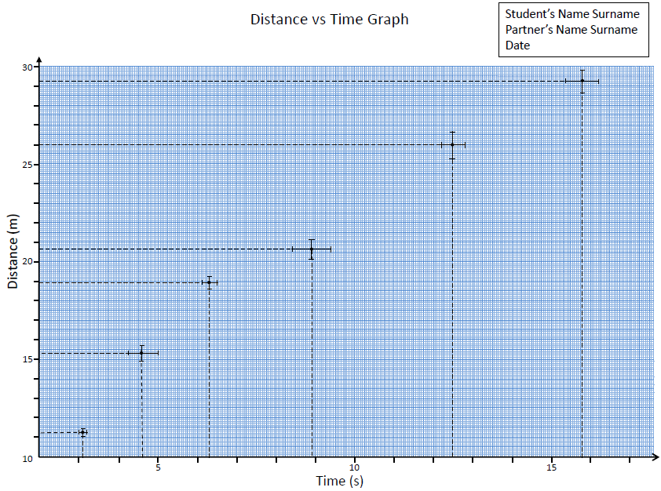
Figure 4. A graph of Distance vs Time.

Analysis of a Straight Line Graph
Two linearly related quantities, x and y, have an algebraic equation of the form:
y = mx + b
where m and b are constants. y vs x graph gives a straight line with slope m, which usually corresponds to a physical quantity in the measurements.
Assume that there are two points (x₁, y₁) and (x₂, y₂) in a data set of a measurement that shows a straight-line behavior when plotted using x and y axis Figure 4.
The changes in x and y axis between these points are defined as Δx = x₂ – x₁ and, Δy = y₂ – y₁ respectively.
Slope, m is expressed as;
m = $\frac{∆x}{∆y}$ = $\frac{y_{2}-y_{1}}{x_{2}- x_{1}}$
In slope calculations, only one data point on the line cannot be chosen. Determining any arbitrary two points on the line is enough to calculate the slope. Because measured points contain an error part, we are required to draw a best straight-line fitting to the data points to calculate the best value of the slope m. A best line is a straight line that best represents the data on the graph.
This line may pass through all, some or none of the data points. The main important point is that an equal number of points lie on each side of the best line.
The best straight line, however, must pass inside as many error bars as possible
In order to calculate the error on m, we need a line that worst fits to the data points. It must be chosen to give the maximum possible deviation from the best line. The drawn line must pass through the error bars of the first and last data points and the worst line must cross the best line.
Best and worst lines cannot be parallel.
The b in the equation is called the intercept and it gives the point at which the straight line crosses the y-axis. Simply, when x= 0, then y = b.
Actually, in the analysis of straight-line graphs, the aim is to determine from the graph the slope as m ± Δm and the intercept as b ± Δb, where Δm and Δb are the maximum possible errors in slope m and in intercept b, respectively.
These errors can be easily determined by drawing the worst possible straight line on the graph. The analysis of this worst possible line is also done in the same way to obtain the worst possible slope m' and the worst possible intercept b’, and then we get the possible errors Δm and Δb as:
Δm = |m - m'|
|and
Δb = |b - b'|
After drawing the best and worst lines, the calculation steps of slope of best and worst line should be shown on the graph as in the example given below in the Figure 5.
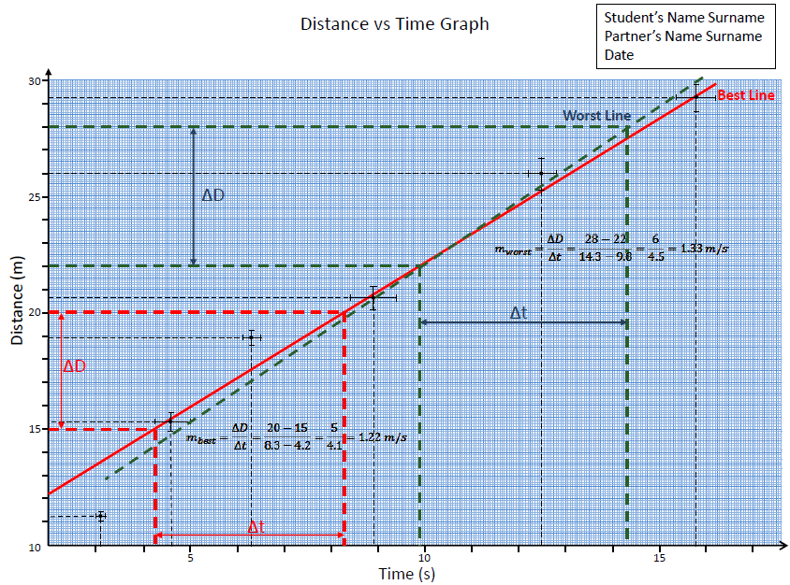
Figure 5. Slope calculations on the graph.

Nonlinear Graphs
In nature, the simplest relation to carry out in the experiments is direct relation as stated in the straight line analysis. However, the other relations are often valid in our daily life.

Inverse Proportion
This graph states that x is inversely proportional to y. This inverse relation can be rewritten as:
yx = k
or,
y = k/x
where k is a constant.
In such a relation, when y versus x graph is plotted, it gives a hyperbolic relation as shown in the Figure 6.
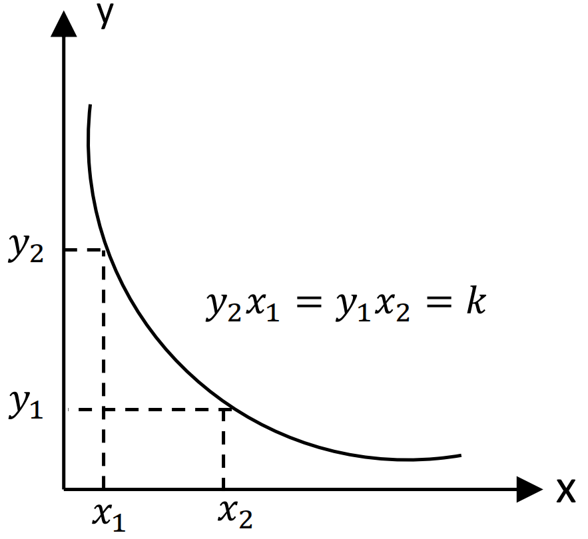
Figure 6. y versus x graph.
However, if the x-coordinate, independent variable is chosen as 1/x, and then, if 1/x versus y graph is plotted (Figure 7), the direct proportion can be obtained.
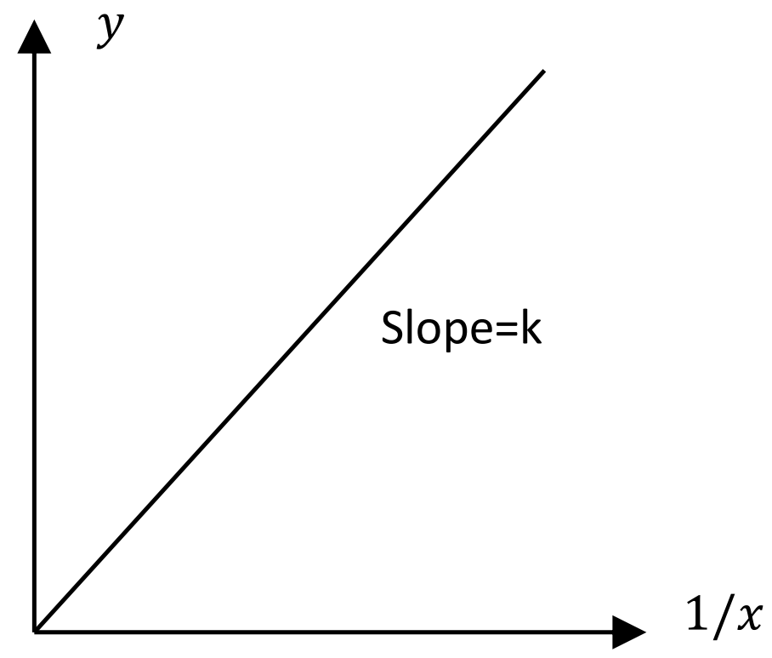
Figure 7.y versus 1/x graph.
Therefore, the experimental data can be studied as to be straight line graph.

A Square Law Graph
A square law relationship between any two variable x and y can be given as
y = kx²
where k again a constant. In this relation, y is related non-linearly to the x. Note that, instead of working on y versus x graph (Figure 8), it is also convenient to use a graph of y versus x². This graphical representation gives a straight line whose slope would be k as shown in the Figure 9 and it would pass through the origin.
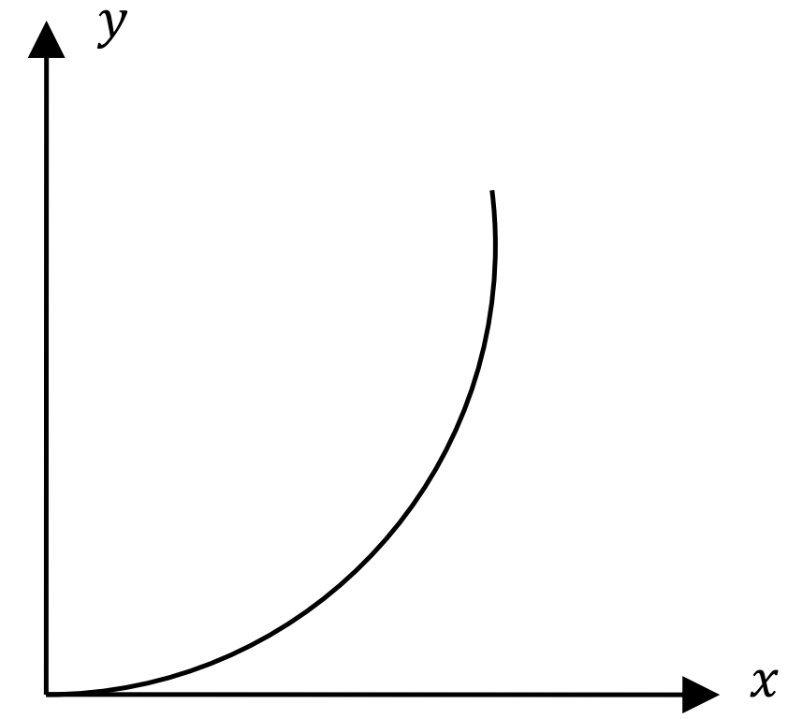
Figure 8. y versus x graph.
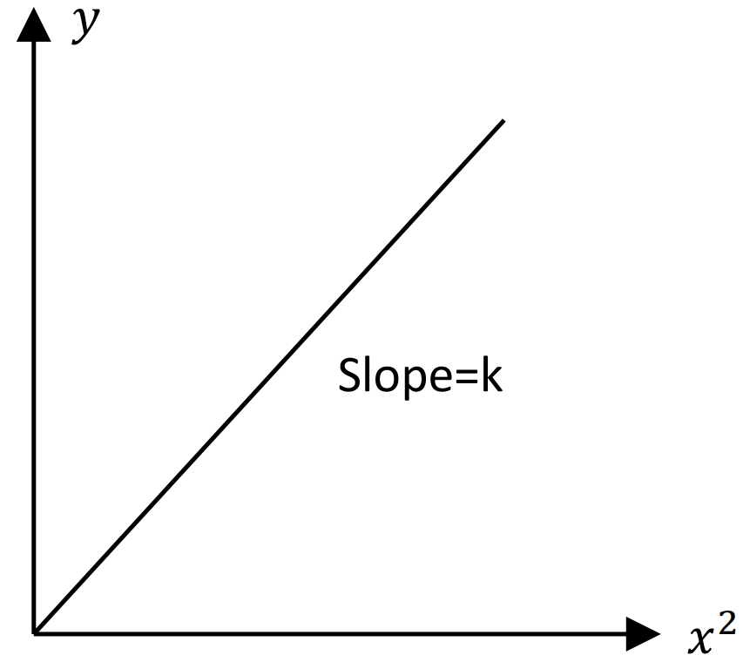
Figure 9. y versus x² graph.

An Inverse Square Law Graph
An inverse square law can be described as
y = k / x²
where k again a constant. In this relation, the variable y is depending nonlinearly on x, but it is depending linearly on 1/x². Therefore, if the x-axis is chosen as 1/x², the corresponding plot gives a straight line with a slope of k.

Exponential Relation
If a graph of x and y has an equation given by
y = ke^{cx}
where c and k are some constants and e is the base of natural logarithm and equal to 2.718, taking the logarithm of both sides of this equation gives a straight line relation as
ln𝑦 = lnk + c𝑥
When lny is plotted as a function of x, the obtained straight-line graph gives the slope as c and the intercept (see Figure 10).
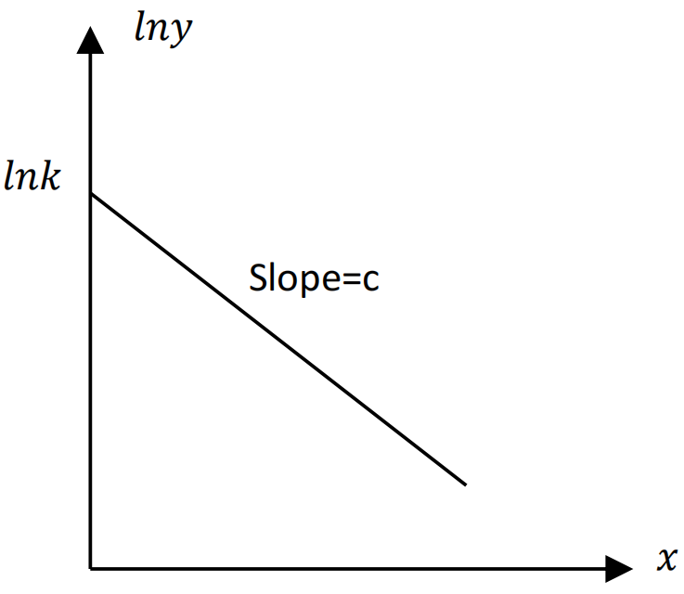
Figure 10. lny versus x graph.
Instead of using natural logarithms to the base 2.718, logarithms to the base 10 can also be used to get a straight line graph. The corresponding equation can be written as
logy =logk + cx
and the graph logy versus x gives the slope as c, and the intercept as logk.

Power Laws
Two variables x and y are related by the general equation,
y = kx^{c}
where k and c are constants. When taking the logarithm of both sides, the equation becomes
logy =logk + clogx
where it is in a straight-line characteristics.
When logy is plotted as a function of logx, obtained straight line gives the slope c and the intercept logk.
Instead of using logarithms to the base 10, natural logarithms to the base 2.718 can also be used to get a straight-line graph. The corresponding equation can be written as
lny =lnk + clnx
and the graph lny versus lnx gives the slope as c, and the intercept as lnk.

Section Number: PHYS1103. ___ Date:__/__/____
Group Number:___
 | Dept | Student Number | Name | Surname | Task Distribution
1
2
3

Objectives
- Learn how to use caliper,
- Measure external dimensions (length, volume) of a given regular body,
- Determine depth of a given object using a caliper,
- Determine the possible errors in the measurements by ruler and caliper and compare their accuracy,
- Determine the density of a regular body of known mass using different measurement techniques.

Equipment List
- Cylindric Object with Holes
- Prismatic Object
- Digital Balance

Set-up and Procedure:
Measure all dimensions of the Rectangular Prism in Part 1 and the Cylinder with Holes in Part 2 using ruler and caliper. Then measure the mass of each object to calculate their densities. Fill the related tables in each Part with the data obtained and the calculated values from measurements.

PART 1. Rectangular Prism
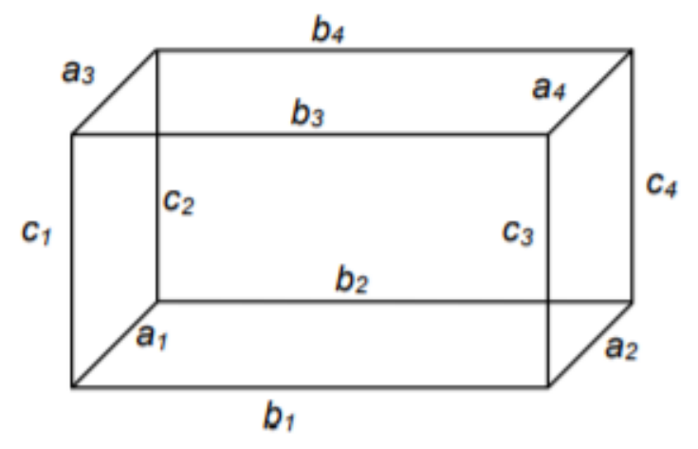
Figure 11. Dimension of Rectangular Prism

Table 3. Measuring dimension of the Rectangular Prism with ruler
Ruler (cm) | a ± Δ a | B ± Δb | c ± Δc
1
2
3
4
5
Average

Table 4. Measuring dimension of the Rectangular Prism with caliper
Ruler (cm) | a ± Δ a | b ± Δb | c ± Δc
1
2
3
4
5
Average
From data measured by ruler and caliper take the final average of the all average values to determine dimension of a, b and c with their uncertainties. Then calculate V± ΔV and explicitly show the details of your calculation.
Table 5. Average values
 | Ruler | Caliper
a ± Δ a (cm)
b ± Δb (cm)
c ± Δc (cm)
V± Δ V (cm³)
m ± Δ m (gr)
Density ρ ± Δρ (g/cm³ )
Calculaions:

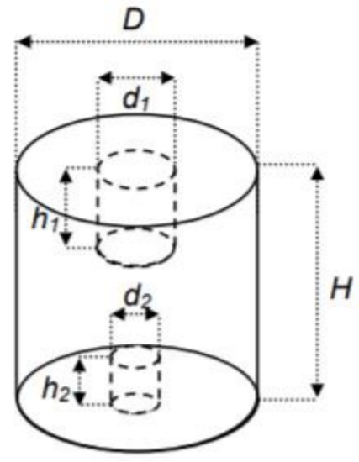
PART 2. Cylinder
Figure 12. Dimension of Cylinder

Table 6. Measuring dimension of the Cylinder with ruler
Ruler (cm) | D ±Δ D | H ±ΔH | d1 ±Δd1 | h1 ±Δ h1 | d2 ±Δ d2 | h2 ±Δ h2
1
2
3
4
5
Average

Table 6. Measuring dimension of the Cylinder with caliper
Ruler (cm) | D ±Δ D | H ±ΔH | d1 ±Δd1 | h1 ±Δ h1 | d2 ±Δ d2 | h2 ±Δ h2
1
2
3
4
5
Average

From data measured by ruler and caliper take the final average of the all average values to determine dimension of a, b and c with their uncertainties. Then calculate V± ΔV and explicitly show the details of your calculation.
Table 5. Average values
 | Ruler | Caliper
D ±Δ D (cm)
H ±ΔH (cm)
d1 ±Δd1 (cm)
h1 ±Δ h1
d2 ±Δ d2
h2 ±Δ h2
V± Δ V (cm³)
m ± Δ m (gr)
Density ρ ± Δρ (g/cm³ )
Calculaions:

